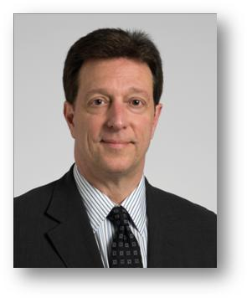**William A. Donato**

**Executive Director Supply Chain Management**

Description: cid:034324620@07102010-185E

Bill Donato joined the Cleveland Clinic Foundation in May 2009. As a direct report to the COO, Bill is responsible for the overall strategic direction and management of all supply chain functions within the organization and provides oversight of $2 billion in spend. Bill and his team are responsible for creating, implementing, transforming and leading the Global Supply Chain process. Bill oversees all related functions within the US and provides support for all international supply chain operations. Bill is a staff member and a system wide leader interacting, influencing and collaborating with all functions of the corporation.

Prior to joining the Clinic, Bill worked at Ethicon, a Johnson & Johnson Company for fifteen years. Bill held the position of Vice President, Contracting & Compliance for Ethicon Inc. In this role, Bill had leadership responsibility for all contracting, pricing, contract administration and compliance for the Ethicon Franchise. Bill assumed this assignment in June of 2004.

Prior to that, Bill was the Vice President of Marketing for Ethicon Products (2001-2004). In this capacity, Bill’s responsibilities included U.S. Product Marketing, Strategic Marketing/Pipeline Development, Market Research/Business Analytics and Professional Education.

Bill joined Ethicon in 1994 as Director, Health Economics and Reimbursement. His focus was on the commercialization of new technologies, with an emphasis on economic outcomes, value propositions and reimbursement strategies. In 1998, Bill accepted the assignment of Group Product Director, Marketing, which he held until 2001.

Prior to joining Ethicon, Bill held senior leadership roles with two Group Purchasing organizations, the Sun Health Alliance in Charlotte, North Carolina and SSM-DHS in Milwaukee, Wisconsin.

Bill holds a BA in Business Economics from Benedictine University and completed the Johnson & Johnson Executive Development Program at the Theseus Institute, France.

**Selected Awards/Honors**

Ethicon Inc. President’s Gold Awards (1995, 1998, 1999, 2000)

Johnson & Johnson Standards of Leadership Awards (2004, 2005, 2006)